Virtual Mogul
Super Funnel Opportunity

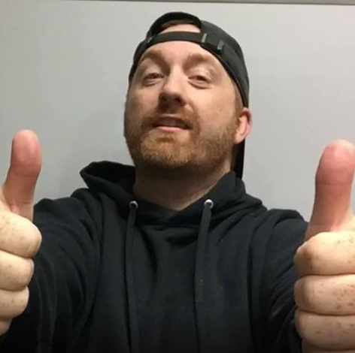

Congratulations on taking advantage of the Virtual Mogul SUPER FUNNEL Opportunity! This is going to allow you to get 100% commissions through my entire funnel!

Please follow the instructions below to get started!!! Enjoy!

Step 1. Go to WarriorPlus and log in.

Step 2. Click on the Affiliate Tab and then click on the Offers sub tab like in the picture below: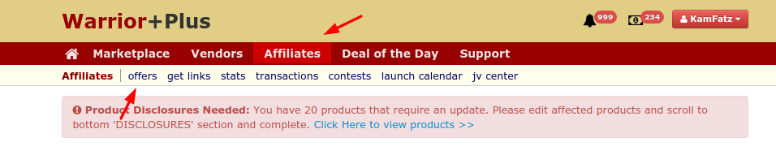

Step 3. Search for Virtual Mogul:
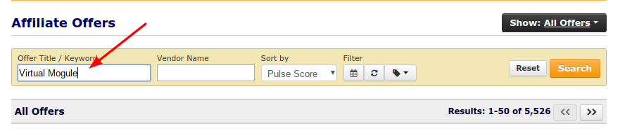
Step 4: Request to affiliate with Virtual Mogul: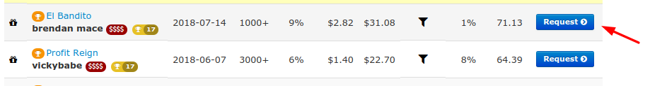
Step 5: Reach out to me by email at Kamjenningspro@gmail.com and put “Virtual Mogul Super FUnnel Opportunity” in the subject line

Step 6: I will get back with you within 24 hours confirming your new affiliate status as a super funnel user.

If you have any questions whatsoever do not hesitate to contact me by email at kamjenningspro@gmail.com. I check my email several times a day and will get back with you within 24 hours.

